Game Design Document

Fill up the Following document

1. Write the title of your project.

Save the nemo!

1. What is the goal of the game?

The gole of the game is to save your self from the shark

1. Write a brief story of your game?

There is a fish family.they had a beautiful howse bilt by the the leavs and flowers.there was a hungary shark which did not eat for 2 days so the shark wanted food then the shark say this fish family.then this shark was trying to catch the fish family then they start to run……

1. Which are the playing characters of this game?

* Playing characters are the ones which respond to the user based on the input from the user
* Cars, monkeys, dinos, wizards etc, are the playing characters in the game.

|  |  |  |
| --- | --- | --- |
| Number | Character Name | What can this character do? |
| 1 | Fish 1 (nemo) | Run away from the shark |
| 2 | Fish 2 (nemo’mom) | Help nemo run away from fish |
| 3 |  |  |
| 4 |  |  |
| 5 |  |  |
| 6 |  |  |
| 7 |  |  |
| 8 |  |  |

1. Which are the Non Playing Characters of this game?

* Non Playing characters are the ones which don't have an action or a behaviour when the user interacts with the game.
* Hurdles, stones, bananas, coins, etc are non playing characters in the game.

|  |  |  |
| --- | --- | --- |
| Number | Character Name | What can this character do? |
| 1 | Fish 3 (nemo’s dad) | Run away from shark |
| 2 | Fish 4 (nemo’ grandmom) | Run away from shark |
| 3 |  |  |
| 4 |  |  |
| 5 |  |  |
| 6 |  |  |
| 7 |  |  |
| 8 |  |  |

Draw your imagination of this game. What does this game look like?

* Draw the game either on your computer or on paper,
* Add images of scenes of the game to show each of the playing and non-playing characters at least once.

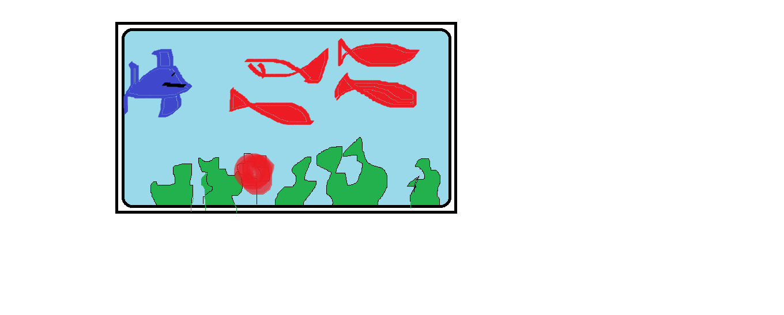

How do you plan to make your game engaging?